**Cumberland Lodge Fellowship 2023-25**

Cumberland Lodge is an educational charity which convenes discussions on pressing issues in society. We also host public-facing educational, cultural, and social events. Involving young people – including our Fellows – in all that we do is a priority for us.

Every year, the Cumberland Lodge Fellowship gives 10 doctoral students the opportunity to get involved in our work; bringing together people from different backgrounds, ages, and perspectives, to address the causes and effects of social division and work towards more open and inclusive societies.

Our Fellows join a growing international and inter-generational movement for social progress and are given numerous opportunities to connect with others who share a commitment for using their intellectual and other abilities to work for the betterment of society.

During the two-year scheme, Fellows have opportunities to take part in our Programme events and consultations at St George’s House in Windsor, pushing their boundaries beyond their own academic disciplines. In doing so, they will gain experience in working collaboratively; engaging in cross-disciplinary discussion; public engagement and facilitation at events; networking; and writing for a range of different audiences.

The Fellowships fit around the demands of doctoral research. They are open to students of any age who are enrolled on a doctoral programme within the UK.

**Applicants must:**

·         have at least two years left to complete their PhD (completion not before June 2025)

·         be studying at a UK university and living in the UK

·         provide two referees (one academic, one non-academic)

·         be able to attend the residential Fellows’ Retreat at Cumberland Lodge on 8-10 September 2023.

All types of doctoral candidates from any UK university are eligible to apply, including full-time, part-time and those on non-traditional pathways and professional doctorate programmes. Since 2014, 76 students have enjoyed/are currently enjoying the benefits of this programme.

Full information about the scheme and how to apply can be found on the [Cumberland Lodge Fellowships](https://www.cumberlandlodge.ac.uk/what-we-do/cumberland-lodge-fellowships) webpage, which includes:

1.     The application form, to be returned to us by **12noon on Wednesday 31 May 2023.**

2.     The application pack, containing further details about the scheme.

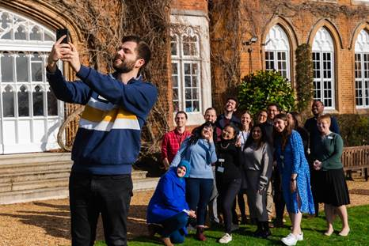

If you have a physical noticeboard within your department, there is an A4-sized poster in the downloads section of [the Cumberland Lodge Fellowships webpage](https://www.cumberlandlodge.ac.uk/what-we-do/cumberland-lodge-fellowships), which contains all the details that a prospective Fellow would need to know before applying. We encourage you to share this physically or virtually with your students.

**Webinar for prospective Fellows**

On **Wednesday 10 May at 4pm BST**, we will be hosting a webinar with current and alumni Fellows. The webinar will serve as an opportunity for prospective Fellows to learn more about the scheme, its benefits, and its objectives, from those with first-hand experience. It will also give interested students the opportunity to ask questions directly to those taking part in the scheme. The link to register is below, and the webinar will be available on-demand after the event.

Link to register for the webinar: <https://us02web.zoom.us/webinar/register/WN_c8uJBNQoQR-L11GE7hhunw>

If you have any further questions, please don’t hesitate to get in touch via [programmeteam@cumberlandlodge.ac.uk](mailto:programmeteam@cumberlandlodge.ac.uk).